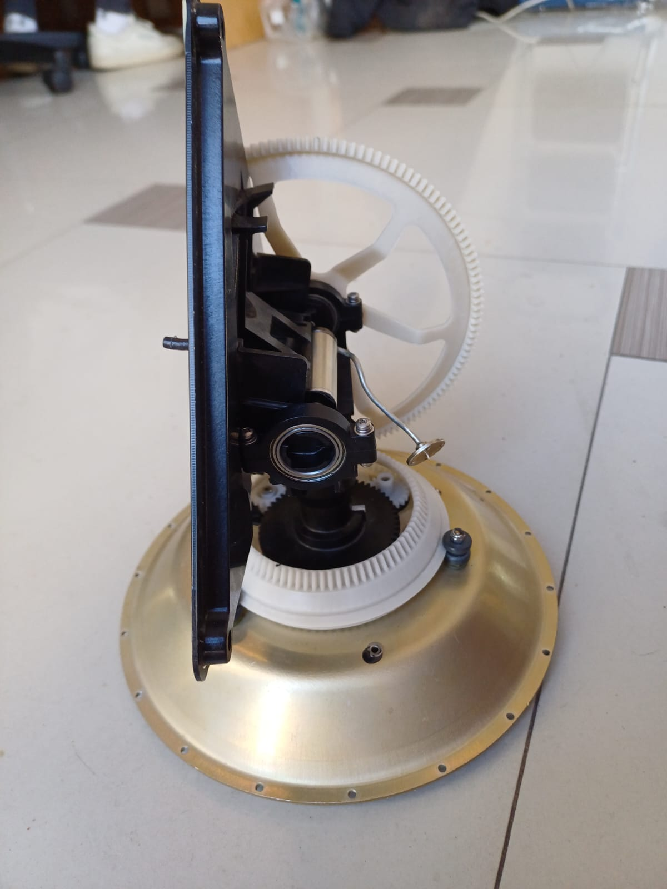

**Gear D­­­­**

**Gear C**

**Gear A**

**Gear B**

**Gear E**

**Pivot Axle**

**Centre Shaft**